Generative AI-Powered Solutions for Modern Healthcare Specialization
Transform Healthcare Delivery with AI Solutions. Implement AI-powered tools in clinical settings—no coding experience required.
What you'll learn
- Implement GenAI solutions to streamline clinical workflows, enhance diagnostic accuracy, and optimize healthcare operations
- Design ethical frameworks for responsible AI integration in healthcare settings while ensuring regulatory compliance
- Develop practical strategies for AI-powered improvements in clinical documentation, personalized care, and telemedicine security.
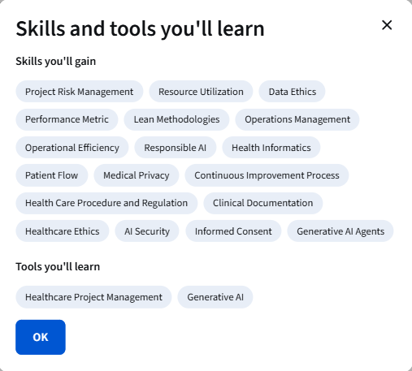
Specialization - 9 course series
Generative AI is revolutionizing healthcare operations, with 75% of healthcare executives believing AI will significantly improve patient care. This specialization equips healthcare professionals, administrators, and technologists with practical skills to implement AI solutions across clinical documentation, diagnostics, patient care, and operations management.
You'll learn to identify opportunities for AI integration, develop implementation strategies, and ensure ethical compliance in healthcare settings. From streamlining clinical documentation to enhancing diagnostic accuracy and securing telemedicine data, this program provides hands-on experience with real-world healthcare scenarios.
Throughout nine courses, you'll progress from understanding foundational GenAI concepts to implementing specialized applications that address critical healthcare challenges. You'll develop skills in prompt engineering, workflow optimization, ethical AI implementation, and project management—all tailored specifically for healthcare environments.
This specialization is ideal for healthcare professionals seeking to drive innovation, administrators looking to optimize operations, and technologists aiming to specialize in healthcare AI implementation. No coding experience is required, though basic familiarity with healthcare processes and terminology will enhance your learning experience.
Applied Learning Project
Throughout this specialization, you'll work on practical projects that simulate real healthcare scenarios. You'll design implementation strategies for integrating AI into clinical documentation workflows, develop ethical frameworks for AI adoption in patient care, create diagnostic enhancement protocols using GenAI tools, and build project management dashboards for healthcare operations. Each project provides hands-on experience applying GenAI solutions to address real challenges in healthcare settings—from improving diagnostic accuracy and streamlining operations to enhancing patient care and securing sensitive health data.
